**BÀI HỌC TRỰC TUYẾN MÔN TIẾNG ANH 7**

**( Từ ngày 11/10- 16/10/2021)**

**Unit 3 : AT HOME**

**PERIOD 6 : A3- A4**

Task 3. Look at the picture. Then practice with a partner.  
  
**a. Point and Say.**

What is in the picture?

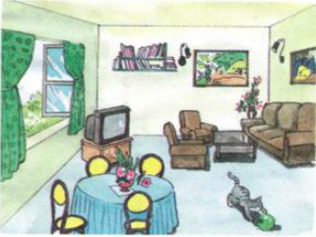

**b. Ask and answer.**

Is there a...?

Yes, there is./ No, there isn’t.

Where is it?

It is on/in/under/near/next to/ behind/ in front of...

Are there any ...?

Yes, there are./ No, there aren't.

Where are they?

They are on/in/etc,...

**Task 4. Play with words.**

